**Guided Capstone Project Report**

**1. Introduction**

Big Mountain Resort, a ski resort located in Montana.Every year about 350,000 people ski or snowboard at Big Mountain.Big Mountain Resort has recently installed an additional chair lift to help increase the distribution of visitors across the mountain. This additional chair increases their operating costs by $1,540,000 this season. The resort's pricing strategy has been to charge a premium above the average price of resorts in its market segment.

**2. Data Analysis**

Initial analysis of ticket price was done in different state based on number of resort in a state or total skiing area but not much found.

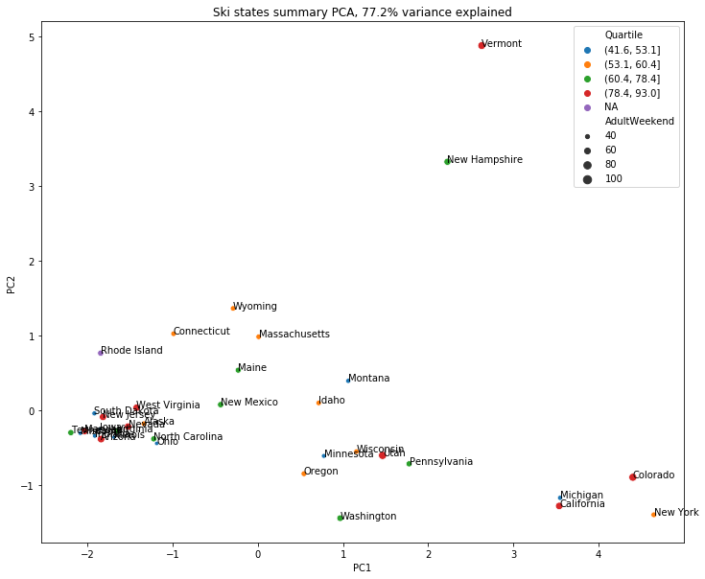

But after applying principle components analysis (PCA) on the data it was found spread in quartile and something is affecting ticket price.

The mapping of ticket price to individual feature was done and positive correlation of ticket price with vertical drop , fast quads , number of runs , total acre covered by snow and night skiing was found.

**3. Comparison**

The data of Big Mountain was compare with other resort on these key featurea mentioned

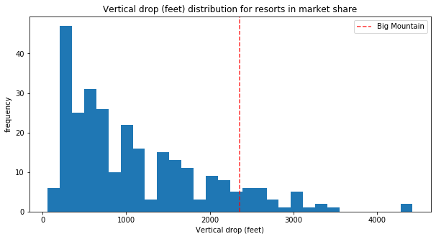

Big Mountain is doing well for vertical drop, but there are still quite a few resorts with a greater drop.

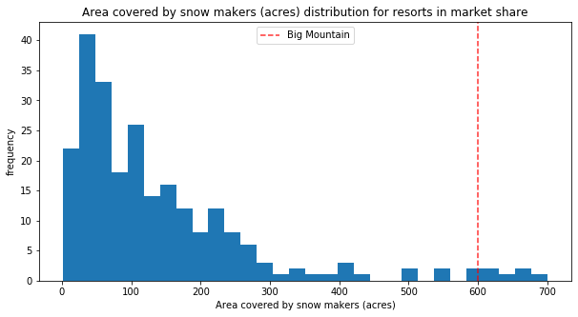

Big Mountain is very high up the league table of snow making area.

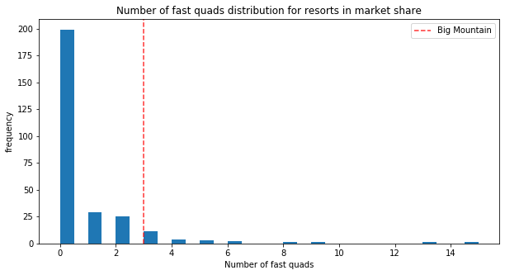

Most resorts have no fast quads. Big Mountain has 3, which puts it high up that league table. There are some values much higher, but they are rare.

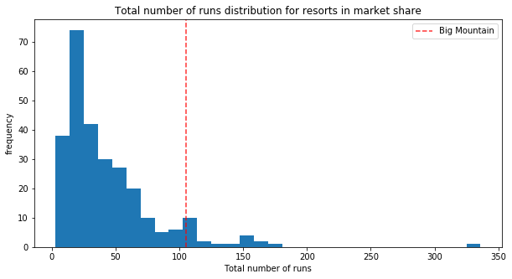

Big Mountain compares well for the number of runs. There are some resorts with more, but not many.

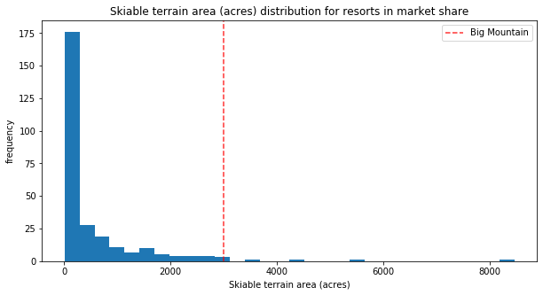

Big Mountain is amongst the resorts with the largest amount of skiable terrain.

## **4. Recommendations**

Using this information a model was build to predict optimal ticket price for Big Mountain.

So the model found some options:-

* Close up to 10 of the least used runs the revenue will drop for around ($3,000,000). The model says closing one run makes no difference. Closing 2 and 3 successively reduces support for ticket price and so revenue. If Big Mountain closes down 3 runs, it seems they may as well close down 4 or 5 as there's no further loss in ticket price
* Increasing the vertical drop by 150 feet, and installing an additional chair lift. This scenario increases support for ticket price by $1.99

Over the season, this could be expected to amount to $3474638